Programming Fundamentals Loops in Java

**Muhammad Saqib**

**Sp20-BSE-069**

# LAB TASKS

1. Write a program to print all natural numbers from 1 to n, using while loop.

package com.company;  
import java.util.Scanner;  
public class Task1 {  
 public static void main(String[] args){  
 Scanner sc = new Scanner(System.*in*);  
 int sum=0;  
 int n;  
 System.*out*.println("Enter n: ");  
 n = sc.nextInt();  
 for (int i=0 ; i<=n ; i++)  
 sum + sum + 1;  
 System.*out*.println("sum of 1 t n,natural numbers is" + sum);  
   
 }  
}

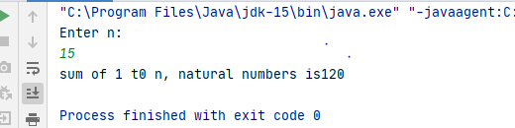

1. Write a program to print all natural numbers from n to 1, using for loop.

package com.company;  
  
import java.util.Scanner;  
  
public class task2 {  
 public static void main(String[] args){  
 Scanner sc = new Scanner(System.*in*);  
 int sum=0;  
 int n;  
 System.*out*.println("Enter n: ");  
 n = sc.nextInt();  
 for (int i=n ; i>=1 ; i--)  
 sum = sum + i;  
 System.*out*.println("sum of n t0 1 , natural numbers is " + sum);  
  
 }  
}

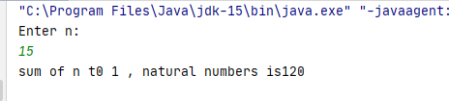

1. Get a number from user. Display its multiplication table using for loop, while loop, and do-while loop.

package com.company;  
  
import java.util.Scanner;  
  
public class task3 {  
 public static void main(String[] args){  
 Scanner sc = new Scanner(System.*in*);  
 int n;  
  
 System.*out*.println("Enter number for table: ");  
 n = sc.nextInt();  
 System.*out*.println("By using while ");  
 int i=1;  
 while(i<=10){  
 System.*out*.println( n + " x " + i + " = " + n*i );  
 i++;}  
  
  
 System.*out*.println("By using for ");  
  
 for ( i=1 ; i<=10 ; i++){  
 System.*out*.println( n + " x " + i + " = " + n*i );}  
  
 i =1;  
 System.*out*.println("By using do while ");  
 do{  
  
 System.*out*.println( n + " x " + i + " = " + n*i );  
 i++;  
 }while (i<=10);  
  
 }  
}

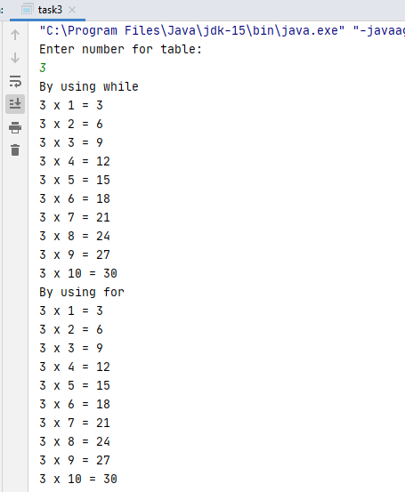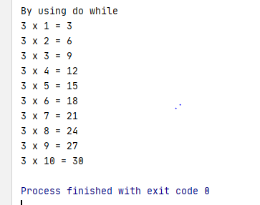

1. Display even numbers from 1 to 100, using all loops. Use ‘continue’ statement to skip odd numbers.

package com.company;  
  
import java.util.Scanner;  
  
public class task4 {  
 public static void main(String[] args) {  
 Scanner sc = new Scanner(System.*in*);  
  
 System.*out*.println(" \n By using while ");  
 int i = 2;  
 while (i <= 100) {  
 if (i % 2 == 1) {  
 i++;  
 continue;  
 } else {  
 System.*out*.print(i + " ");  
 i++;  
 }  
 }  
 System.*out*.println(" \n By using for ");  
  
 for (i = 1; i <= 100; i++) {  
 if (i % 2 == 1) {  
 continue;  
 } else {  
 System.*out*.print(i + " ");  
 }  
 }  
  
 i = 1;  
 System.*out*.println(" \n By using do while ");  
  
 do {  
  
 if (i % 2 == 1) {  
 i++;  
 continue;  
 }  
 else {  
 System.*out*.print(i + " ");  
 i++;  
 }  
  
 } while (i <= 100);  
  
 }  
}

1. Find sum of all odd numbers from 1 to n, using do-while loop.

package com.company;  
  
import java.util.Scanner;  
  
public class task5 {  
 public static void main(String[] args) {  
 Scanner sc = new Scanner(System.*in*);  
  
  
 int i = 1;  
 System.*out*.println(" Enter n : ");  
 int n = sc.nextInt();  
 int sum=0;  
  
 do {  
 if (i % 2 == 0) {  
 i++;  
 continue;  
 }  
 else {  
 sum = sum + i;  
 i++;  
 }  
  
 } while (i <= n);  
 System.*out*.print( "sum of odd number from 1 to n is: " +sum);  
 }  
}

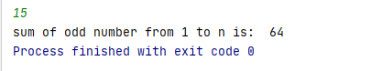

1. Write a program to count number of digits in a number. Take the number from user.

public static void main(String[] args) {  
 Scanner sc = new Scanner(System.*in*);  
 System.*out*.println(" Enter digit : ");  
 int n = sc.nextInt();  
 int sum=0 , turn=0;  
 while(n>0)  
 {   
 n = n / 10;  
 turn = turn+1;  
 }  
 System.*out*.print( " digits : " +turn);  
 }  
}

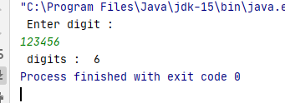

1. Write a program to find n raised to power m (nm).

package com.company;  
  
import java.util.Scanner;  
  
public class task7 {  
 public static void main(String[] args) {  
 Scanner sc = new Scanner(System.*in*);  
 int pow =0 , fix;  
 System.*out*.println(" Enter n ");  
 int n = sc.nextInt();  
 fix = n;  
 System.*out*.println(" Enter m ");  
 int m = sc.nextInt();  
 for(int i = 1 ; i<m ; i++){  
 n = n*fix;  
 }  
 System.*out*.println(n +" raised to power " + m+ " is : " + n );  
 }  
}

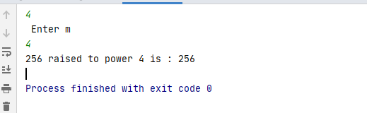

1. Find product of all numbers from 1 to n. This is also called factorial of n or n-factorial.

package com.company;  
  
import java.util.Scanner;  
  
public class task8 {  
 public static void main(String[] args) {  
 Scanner sc = new Scanner(System.*in*);  
 System.*out*.println(" Enter n and get factorial : ");  
 int n = sc.nextInt();  
 int mul=1 , i = 1;  
 while(i<=n)  
 {  
 mul = mul * i;  
 i++;  
  
 }  
 System.*out*.print( "Factorial: " +mul);  
 }  
}

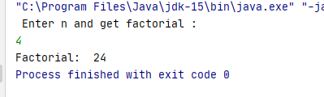

For example, 5-factorial (5!) is 1*2*3*4*5 = 120.

1. Write programs to display following patterns.

|  |  |  |  |
| --- | --- | --- | --- |
| *****  *****  *****  *****  ***** | *****  *****  ***** | *  **  ***  **** | *  **  ***  ****  ***** |
| *****  ****  ***  **  * | 1111  0000  1111  0000  1111 | 01010  01010  01010  01010 | 1111  2222  3333  4444 |
| 12345  12345  12345  12345 | 12345  23456  34567  45678  56789 | 1  22  333  4444  55555 | 1  12  123  1234  12345 |

1. public static void main(String[] args){  
    for(int i=1 ; i<=5 ; i++)  
    {  
    for (int j =1 ; j<=5 ; j++)  
    {  
    System.*out*.print( "*");  
    }  
    System.*out*.println();  
    }  
   }
2. public static void main(String[] args){  
    for(int i=5 ; i>=1 ; i--)  
    {  
    for(int space=i ; space >= 1; space--){  
    System.*out*.print(" ");  
    }  
    for (int j=1 ; j<=5 ; j++)  
    {  
    System.*out*.print( "*");  
    }  
    System.*out*.println();  
    }  
   }
3. public static void main(String[] args) {  
    for (int i = 1; i <= 5; i++) {  
     
    for (int space = 5-i ; space > 0; space--)  
    {  
    System.*out*.print(" ");  
    }  
     
    for (int j = 1; j <= 2 * i - 1 ; j++)  
    {  
    System.*out*.print("*");  
    }  
     
    System.*out*.println();  
     
    }  
   }
4. public static void main(String[] args){  
    for(int i=1 ; i<=5 ; i++)  
    {  
    for (int j =1 ; j<=i ; j++)  
    {  
    System.*out*.print( "*");  
    }  
    System.*out*.println();  
    }  
   }
5. public static void main(String[] args){  
    for(int i=5 ; i>=1 ; i--)  
    {  
    for (int j=1 ; j<=i ; j++)  
    {  
    System.*out*.print( "*");  
    }  
    System.*out*.println();  
    }  
   }
6. public static void main(String[] args){  
    for(int i=1 ; i<=5 ; i++)  
    {  
     
    for (int j=1 ; j<=5 ; j++)  
    {  
    if (i%2==0)  
    System.*out*.print(0);  
    else  
    System.*out*.print(1);  
    }  
     
    System.*out*.println();  
    }  
   }
7. public static void main(String[] args){  
    for(int i=1 ; i<=5 ; i++)  
    {  
     
    for (int j=1 ; j<=5 ; j++)  
    {  
    System.*out*.print( i);  
    }  
     
    System.*out*.println();  
    }  
   }
8. public static void main(String[] args){  
    for(int i=1 ; i<=5 ; i++)  
    {  
     
    for (int j=1 ; j<=5 ; j++)  
    {  
    if (j%2==0)  
    System.*out*.print(1);  
    else  
    System.*out*.print(0);  
    }  
     
    System.*out*.println();  
    }  
   }
9. public static void main(String[] args){  
    for(int i=1 ; i<=5 ; i++)  
    {  
     
    for (int j=1 ; j<=5 ; j++)  
    {  
    System.*out*.print( j);  
    }  
     
    System.*out*.println();  
    }  
   }
10. public static void main(String[] args){  
     for(int i=1 ; i<=5 ; i++)  
     {  
     int x=0;  
     for (int j=1 ; j<=5 ; j++)  
     {  
      
     System.*out*.print(x + i);  
     x++;  
     }  
      
     System.*out*.println();  
      
     }  
    }
11. public static void main(String[] args){  
     for(int i=1 ; i<=5 ; i++)  
     {  
      
     for (int j=1 ; j<=i ; j++)  
     {  
     System.*out*.print( i);  
     }  
      
     System.*out*.println();  
     }  
     }
12. public static void main(String[] args){  
     for(int i=1 ; i<=5 ; i++)  
     {  
      
     for (int j=1 ; j<=i ; j++)  
     {  
     System.*out*.print( j);  
     }  
      
     System.*out*.println();  
     }  
    }

# HOME TASKS

1. Find LCM of two numbers taken from user.

public static void main(String[] args) {  
 Scanner sc = new Scanner(System.*in*);  
 System.*out*.println(" Enter 2 numbers for LCM ");  
 int a = sc.nextInt();  
 int b = sc.nextInt();  
 int i=2;  
 while (true)  
 {  
 if(i % a == 0 && i % b == 0)  
 {  
 System.*out*.println(" LCM IS:" + i);  
 break;}  
 i++;  
 }  
  
 }

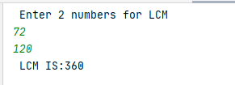

1. Display all prime numbers from 1 to 100.

public static void main(String[] args){  
 for ( int Val = 2 ; Val<=100 ; Val++)  
 { String status ="True";  
 int i=2;  
 while(i<Val)  
 {  
  
 if(Val%i==0)  
 {  
 status="False";  
 break;  
 }  
 i++;  
 }  
 if(status=="True")  
 System.*out*.printf("%d " , Val);  
 }  
}



1. Calculate sum of digits of a number taken from user.

public static void main(String[] args) {  
 Scanner sc = new Scanner(System.*in*);  
 System.*out*.println(" Enter digit : ");  
 int n = sc.nextInt();  
 int sum=0 ,rem ;  
 while(n>0)  
 { rem = n % 10;  
 sum = sum + rem;  
 n = n / 10;  
 }  
 System.*out*.println("Sum of digit is " + sum);  
}

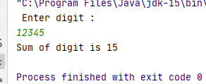

1. Display Fibonacci series up to n terms.

package com.company;  
import java.util.Scanner;  
public class hometask4 {  
 public static void main(String[] args) {  
 Scanner sc = new Scanner(System.*in*);  
 System.*out*.println(" Enter digit : ");  
 int n = sc.nextInt();  
 int nextTerm=0 , sum=0;  
 int t1=0, t2=1;  
 for (int i = 1; i <= n; ++i) {  
 System.*out*.print(" "+t1);  
 nextTerm = t1 + t2;  
 t1 = t2;  
 t2 = nextTerm;  
 }  
 }  
}

